1.Aerial Thermal Imaging Drone
The Aerial Thermal Imaging Drone is equipped with advanced thermal sensors that detect temperature variations in crops and soil. It provides thermal maps that reveal water stress, pest infestations, and soil conditions, critical for maintaining crop health.
Use: This drone is used for field analysis, helping farmers identify areas with irrigation issues, detect heat stress in plants, and monitor soil moisture levels. It aids in precise water management and enhances crop protection strategies.
Significance: The Aerial Thermal Imaging Drone is indispensable for optimizing water use and ensuring crop vitality. By providing real-time thermal data, it allows farmers to respond quickly to irrigation needs, reduce water waste, and prevent crop losses due to stress or pests. This technology contributes to more sustainable and efficient farming practices.
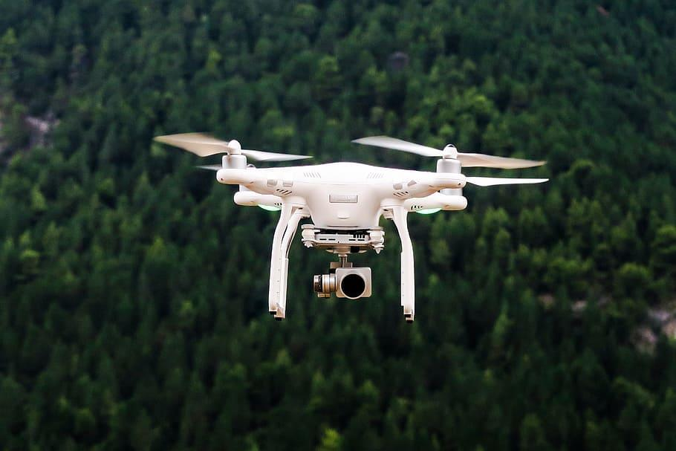

2. LiDAR Drone

Our LiDAR (Light Detection and Ranging) Drone uses laser pulses to create detailed 3D maps of the landscape. It is ideal for mapping terrain, assessing crop canopies, and planning field operations.
Use: LiDAR drones help farmers with precision mapping of fields, assessing the structure and height of crop canopies, and planning effective irrigation and planting strategies. They provide accurate topographical data that is critical for optimizing farm operations.
Significance: The LiDAR Drone is crucial for detailed land assessment and planning. Its ability to create 3D maps enables farmers to understand their fields better, leading to more informed decisions about planting, irrigation, and crop management. This technology supports sustainable farming by optimizing land use and improving operational efficiency.
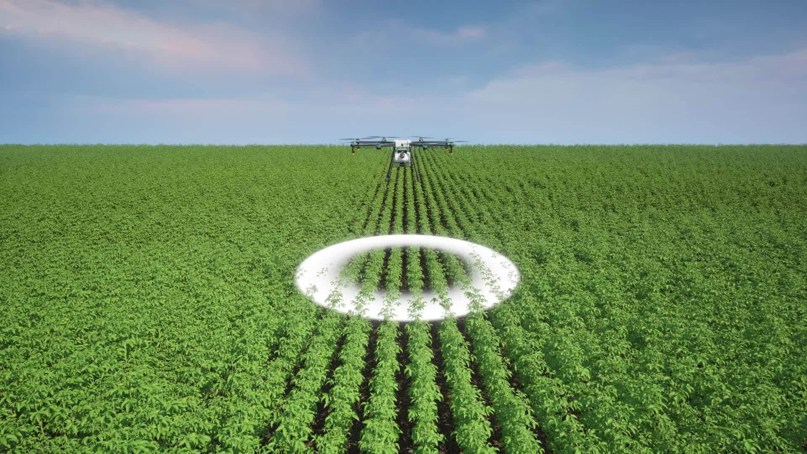

4. Precision Agriculture Drone

Our Precision Agriculture Drone is engineered to optimize crop management through advanced imaging and data analysis. Equipped with high-resolution cameras and sensors, it provides detailed information on crop conditions, soil health, and field variability.

Use: The Precision Agriculture Drone is used to gather data on crop health, monitor soil conditions, and identify areas requiring specific attention. It helps in assessing crop growth stages, detecting pest infestations, and evaluating soil moisture levels with high accuracy.

Significance: This drone enhances precision farming by providing actionable insights that enable targeted interventions and efficient resource use. It supports data-driven decision-making, leading to improved crop yields, reduced input costs, and sustainable farming practices.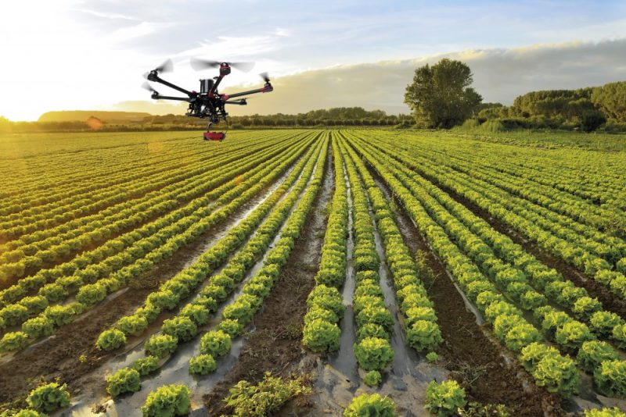

5. Pollen Drone

Our Pollen Drone is an innovative agricultural tool designed to enhance the pollination process. Equipped with advanced pollen dispersal technology, this drone efficiently distributes pollen over crops from the air. It is particularly useful in fields where natural pollinators are limited, ensuring effective and even pollination.

Use: The Pollen Drone is ideal for boosting pollination in orchards and fields, targeting specific plants with precision. It is especially valuable for crops that rely heavily on pollination, such as fruits and nuts. By simulating the natural pollination process performed by bees and other insects, it helps improve fruit set and crop yields.

Significance: Our Pollen Drone provides a reliable alternative to natural pollination, addressing the decline in pollinator populations. It ensures that crops receive the necessary pollen for optimal growth and productivity. This technology is essential for maintaining high crop yields and supporting sustainable agricultural practices.
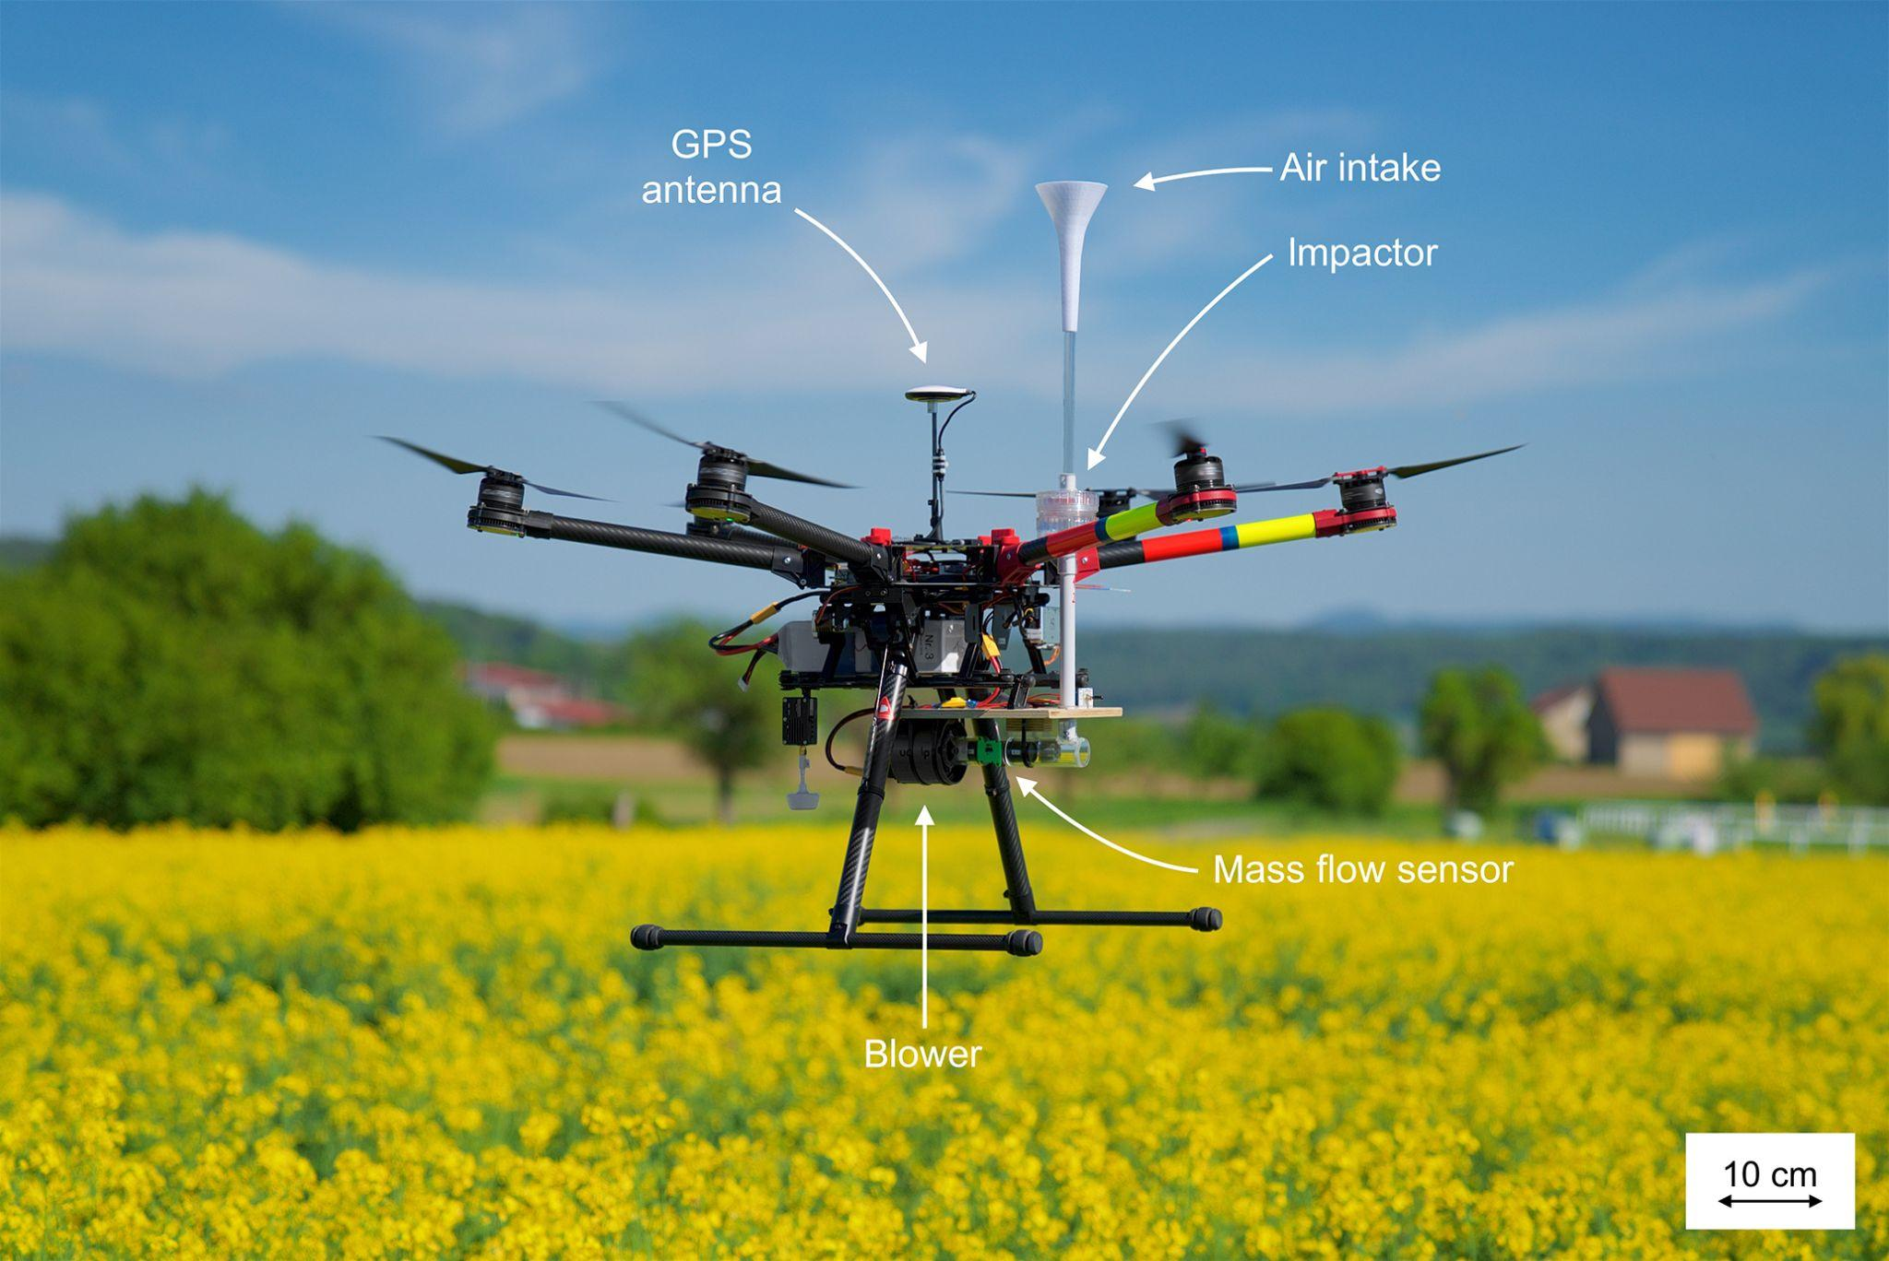

6.Agricultural Drone with Spraying System

Our Agricultural Drone with Spraying System is designed to efficiently apply pesticides, herbicides, and fertilizers across large fields. Equipped with precision spraying technology, it ensures even distribution of chemicals, reducing waste and maximizing effectiveness.
Use: This drone is used for targeted spraying operations, especially in areas difficult to reach by traditional machinery. It allows for precise application of agrochemicals, reducing the amount needed and minimizing the environmental impact.
Significance: This drone is used for targeted spraying operations, especially in areas difficult to reach by traditional machinery. It allows for precise application of agrochemicals, reducing the amount needed and minimizing the environmental impact.
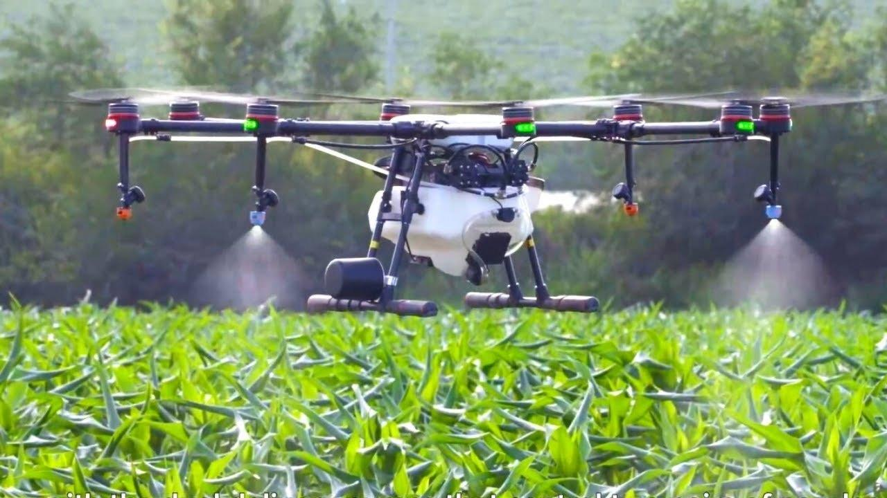

7.Seed Drone

Our Seed Drone is a cutting-edge agricultural device engineered to revolutionize the planting process. Featuring state-of-the-art seed dispersal technology, this drone efficiently plants seeds across extensive areas from the air. Ideal for applications ranging from large-scale agricultural fields to reforestation and cover crop planting, it simplifies and accelerates the planting process.
Use: The Seed Drone excels in planting seeds quickly and accurately, even in challenging or hard-to-reach terrains. It is perfect for large-scale farming operations, reforestation projects, and no-till farming systems. By automating the seed distribution process, it ensures optimal seed placement and coverage.
Significance: The Seed Drone excels in planting seeds quickly and accurately, even in challenging or hard-to-reach terrains. It is perfect for large-scale farming operations, reforestation projects, and no-till farming systems. By automating the seed distribution process, it ensures optimal seed placement and coverage.

